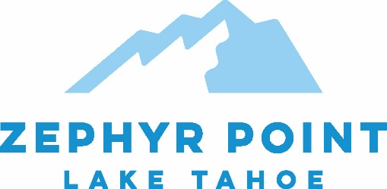
JOB ANNOUNCEMENT
Director of Development
Full-time, Year-round
Posting Date: December, 2022

To apply and/or for questions - email resume and cover letter to: dyoung@zephyrpoint.org

Zephyr Point Presbyterian Conference Center, located on 24 acres on the east shore of Lake Tahoe, will mark 100 years of ministry in 2024. From its humble beginnings holding Youth Conferences tent camping by the lake, Zephyr Point is today a modern Camp and Conference Center hosting over 25,000 guests per year. Two fully equipped Conference Centers with 102 hotel style rooms, two dormitory style facilities, and over 40 rustic cabins comprise our lodging options for retreats, gatherings, and getaways of almost any size. Alongside the hosting of retreats, Zephyr Point has a diverse offering of year-round Programs for Adults, and an 8 week Summer Camp Program for Youth.
If you can get excited about Zephyr Point’s Mission/Vision/Values, would like to be part of a dynamic leadership team, have a passion for the outdoors and the experience to lead our Business and Donor Development efforts, this position may be for you!
TITLE: Director of Development
SUMMARY: The Director of Development will provide leadership for the Zephyr Point Development Department, coordinating all Donor and Business Development efforts.
COMPENSATION: $60-80k DOE, with on-campus housing provided; full benefit package including medical and retirement benefits through the PC(USA) Board of Pensions
STATUS: Full-time
CLASSIFICATION: Exempt
SUPERVISOR: Executive Director
DIRECT REPORTS: Senior Engagement Associate; Communications and Marketing Manager
QUALIFICATIONS: Bachelor’s degree required; Graduate degree in related field desired. Minimum 5 years fundraising experience, and at least 3 years management experience in sales, marketing, or public relations.

For full job description and application: Join our Team - Zephyr Point

