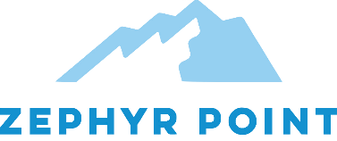
Donate $100+ to Zephyr Point
Oct. 1st, 2020 to Nov. 30th, 2020
And you will be entered into our drawing

Grand Prize is a 1-Week stay
in Cabin #8 June 12th, 2021 to June 19th, 2021
Additional prizes will be
announced at the live event

Drawing will be held live on Facebook
December
4
Friday
4:00 pm Pacific Time

https://www.facebook.com/zephyr.point/

Donate online: https://www.zephyrpoint.org/
By mail: Zephyr Point PO BOX 289 Zephyr Cove, NV 89448
Or
Call Katie Keith 775-588-6759 Ext 107

